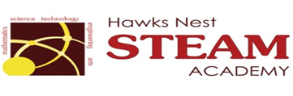School Counseling Program Newsletter
Shandrai Silva, School Counselor | October 2018

Counselor Message  The 2018-19 school year has gotten off to a fantastic start! In September, we celebrated International Dot Day. In guidance classes, students had a wonderful time learning about themselves and exploring how they can make their mark. For our Make Your Mark service project, students made greeting cards for members of our community. We also recognized International Day of Peace in September by wearing white and students learning more about peace and how to be Peacemakers in guidance classes. We have had lessons on being bucket fillers and started our Digital Citizenship lessons.  In October, we’ll recognize Red  Ribbon Week and National Bullying  Prevention Month. Student Council  elections are coming up. So, students in  grades 3-5 will start campaigning at the  end of the month. Classroom guidance  lessons will continue and small group  planning is underway. Have ideas for  the school program, please feel free to  share them with me. Contact  information is below.  How to see the school counselor  Classroom guidance classes, small group  counseling and individual counseling by  self -referral, parent referral, teacher  referral, administrator referral or counselor  initiated.  Contact School Counselor at 704-866-8467or sosilva@gaston.k12.nc.us. | Home of the Hawks  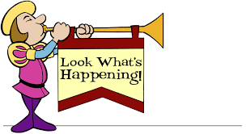  Bullying Prevention Month  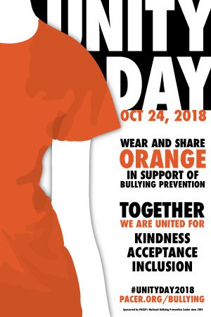  Red RibbonWeek  October 22-26, 2018  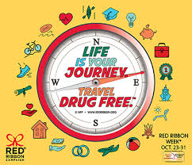 | Character Education  “We’re Soaring with Good Character”  ______________________________  The character trait of the month is Fairness. Fairness is taking turns, sharing, and listening to what others have to say; treating others respectfully.  ______________________________________________  Promoting Character Education  “Fairness does not mean everyone gets the same. Fairness means everyone gets what they need.” - Rick Riordan  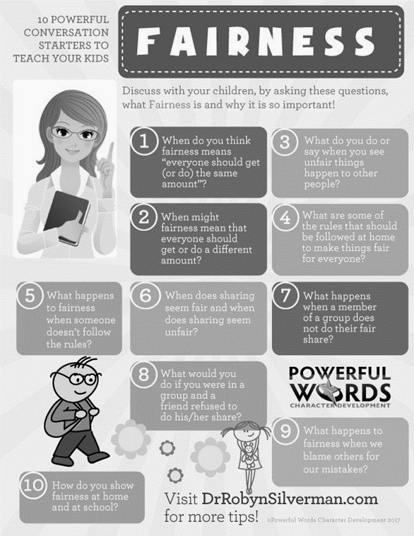  https://drrobynsilverman.com/2017/10/11/parents-talk-kids-fairness/10-powerful-conversation-starters-fairness/ 